Article Title (The title should be a declarative phrase without punctuation at the end and at least 7 words but no more than 25 words)
Firstname Lastname¹, Firstname Lastname², Firstname Lastname^{2, *}
¹Department, Institution, City, Country
²Department, Institution, City, Country
Email address:
email1@authorname.com (Author Name1), email2@authorname.com (Author Name2), email3@authorname.com (Author Name3)
*Corresponding author
ORCID:
ORCID1 (Author Name1), ORCID2 (Author Name2), ORCID3 (Author Name3)
Note: (Please remove this note once you have completed this section.)
1. There should be no job titles or degree before the author's name.
2. Authors are recommended to provide the 16-digit ORCID.
To cite this article:
Author's Name. (Year). Article Title. Journal Title, Volume (Issue), Page Range. DOI.
Received: MM DD, 2023; Accepted: MM DD, 2023; Published: MM DD, 2023

Abstract: The abstract should be a concise single paragraph, ranging from 150 to 300 words and should not include any reference citations or footnotes. It should provide a brief overview of research problem, purpose/general objective, method, result and conclusion. It is important to ensure that the abstract presents an objective summary of the article body. Inclusion of results that are not substantiated in the main text should be avoided. Abstract should be standalone summary of the whole research and as such all abbreviations and acronyms used should be written in full in their first instance.

Keywords: Keyword1, Keyword2 … Keyword8 (Provide 3-8 relevant keywords or phrases for complex words that represent the main content of the article. These keywords should be specific to the article and commonly used within the subject discipline for indexing purposes.

1. Introduction

In the Introduction section ought to cover brief background of the study; the purpose and rational of the research; research problem. Provide accurate intext citation. Consider using sub sections if necessary for clarity and organization. Abbreviations and acronyms used in the text must be defined in full at their first mention in the text.
2. Literature Review
The article should be written in English. An article should be between 6 and 25 pages, and exceed 2000 words. For original research articles, it should include the headings Introduction, Materials and Methods, Results, Discussion and Conclusions. Other types of articles can be written with a more flexible structure.
2.1. Headings Level 2
The headings or subheadings should be numbered consecutively. Each headings or subheadings should not exceed 3 lines. There should be at least 2 subheadings under each heading but no more than 5 subheadings under one heading.
(Main Text Paragraphs)
2.1.1. Heading Level 3 (Optional)
(Main Text Paragraphs)
2.1.2. Heading Level 3 (Optional)
(Main Text Paragraphs)
2.2. Heading Level 2
Equations and Formulas: Please use either the Microsoft Equation Editor or the MathType add-on when including equations. All equations should be consecutively numbered using Arabic numerals within parentheses, such as (1), (2), (3)...Please ensure the formulas and equations are editable, and include them in the text. Ensure clear presentation of formulas and equations, with proper symbol definitions.
Y_{it} = β_{O}+β₁X_{it}+β₂Z_{it}+β₃U_{it}+ε_{it}………………………………………………………….…………………………….…………. (1)
Z²-X²=Y…………..……………………………………………………………………………………………………………...(2)
Figures: Each figure should have a concise caption describing what it represents. Figure captions should be presented below the figures, not in the figure file. Figures must be consecutively numbered using Arabic numerals, such as Figure 1, Figure 2, Figure 3...
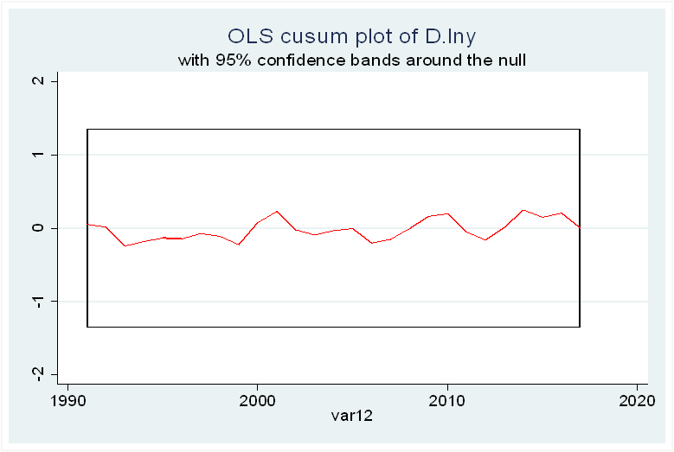
Figure 1. Figure caption.
Nyamweya and Obuya (2023)

Tables: Each table should have a clear caption describing what it represents. Table captions should be presented above the tables. The corresponding meaning of the symbol in the table should be given below the table. Tables must be consecutively numbered using Arabic numerals, such as Table 1, Table 2, Table 3...
Table 1. Table caption.
Column 1 | Column2
Row1 | R1
R2 | R2
R3 | R3
R4 | R4
R5 | R5
R6 | R6
3. Methodology
The methodology should cover research philosophy, research design, target population, sampling design, data collection process, data analysis and presentation. The methodology section should provide comprehensive details to enable other researchers to replicate the study and further expand upon the published results. Consider using subsections with appropriate headings to enhance clarity and organization.
4. Results
The results section should provide an accurate and concise description of the findings, and the resulting conclusions that can be inferred from the findings. The results should be objective avoiding any fabrication or improper manipulation of data. Where applicable, results of statistical analysis should be included in the text or as tables and figures.
5. Discussion
In this section, authors are advised to provide a thorough analysis of the results and make comparisons with relevant literature, not a short summary or conclusion. Avoid tables and figures in the discussion of findings
6. Conclusions
The conclusion section should articulate the main findings of the article, emphasizing its significance and relevance. Authors to avoid including tables and figures in the conclusion.
Funding (Optional)
Authors are expected to disclose all sources of research funding, including grants supporting the work and any received funds covering publication costs.
Acknowledgments (Optional)
This section serves to recognize contributions that do not meet authorship criteria, including technical assistance, donations, or organizational aid. Individuals or organizations should be acknowledged with their full names. The acknowledgments should be positioned after the conclusion but before the references section in the manuscript.
Conflicts of Interest
Authors to disclose any financial, commercial, or other affiliations that could be perceived as potential conflicts of interest by the academic community. In the absence of such relationships, authors will be requested to confirm the following statement:
“The authors declare no conflicts of interest.”

References
It is the author's responsibility to ensure the completeness and accuracy of the information in each reference. All in-text citations must appear in the references. References can be in any style or format as long as consistency is maintained. When applicable, include the author(s) name(s), chapter title/article title, journal title/book title, publication year, volume number/book chapter, and article number or page range. The inclusion of DOI or permanent link in the reference is highly encouraged. Example of Journal Article reference in APA format.

[1] Author 1, Author 2, Author 3. Year. Article Title. Journal Title. Volume (Issue), Page Range. DOI or URL (Journal Articles)
Example:
Obuya, M. O. & Olweny, T. (2017). Effect of Bank’s Lending Behaviour on Loan Losses of Listed Commercial Banks in Kenya. International Journal of Management and Commerce Innovations, 5(1),135-144. doi: 10.11648/j.ijmsa.20221103.12
[2] Author 1, Author 2, Author 3. Year. Book Title. Edition. Publisher Location: Publisher (Books)
Example:
Cozby, P. C., Bates, S. C. Methods in behavioral research. New York, NY: McGraw Hill; 2012.

